

Dr. Lisa, Ross inc.

2016-07-18

Dr. Ross

61046 Jennifer Stravenue, Greertown, ND 00965

Phone: 7736761645

Fax: 286172019

**Re:** Cheryl, Blevins

**PHN:** 2148154575

**Birthdate:** 02-Jun-1970

**Address:** 57770 Nathan Rue, Port Cherylborough, FM 06127

**Patient number:** 2407053461

To Whom It May Concern:

This is a medical letter to state the above patient is pregnant with expected delivery date of 21-Oct-2025. Hoping this information is satisfactory for your requirements.

Thank you.

Sincerely,

Dr. Lisa, Ross

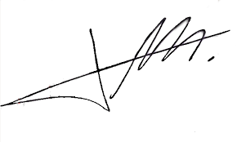

FRCS© NCMP

Clinical Assistant Professor, UBC

Department of Obstetrics and Gynecology SMH